***Static Website Hosting with AWS S3:***

Amazon S3 (Simple Storage Service) is an AWS cloud storage solution, offering secure and scalable data storage accessible globally on the internet.

We opt for Amazon S3 to host websites (in my cases I hosted simple gallery website) due to its scalability, cost-effectiveness, and reliability. S3 simplifies the storage of static website content, and its seamless integration with AWS services ensures efficient deployment and worldwide accessibility. The pay-as-you-go pricing model makes it budget-friendly for hosting websites with varying traffic.

ARCHITECTURAL DIAGRAM

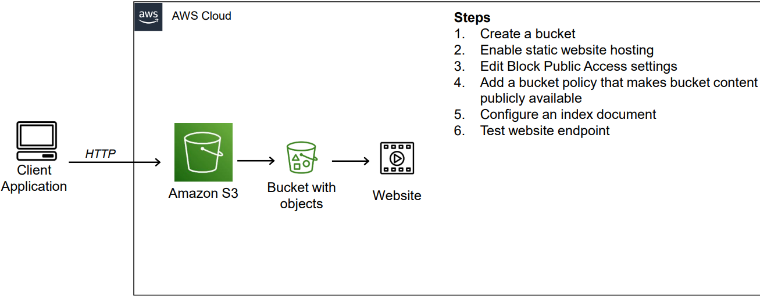

Step-by-Step Instructions:

**1. Creating a Bucket:**

* Go to the AWS Management Console > Select S3.
* Create a unique bucket with ACL enabled for object ownership.
* Uncheck block public access.
* Create the bucket.

**2. Uploading Content to S3 Bucket:**

* Upload the index.html file.
* Upload image files if necessary.

**3. Changing Object Permissions:**

* Select the object > Go to properties > Enable website hosting.
* Save changes.
* Select the object again > Go to action > Make it public using ACL

**4. Testing the Website:**

* Copy the object URL.
* Paste the URL in any browser.
* Your website should be visible.

